1.6.1 Packet Tracer - Implement a Small Network
Addressing Table
Device | Interface | Address | Subnet Mask | Default Gateway
RTA | G0/0 | 10.10.10.1 | 255.255.255.0 | N/A
 | G0/1 | 10.10.20.1 | 255.255.255.0 | N/A
SW1 | VLAN 1 | 10.10.10.2 | 255.255.255.0 | 10.10.10.1
SW2 | VLAN 1 | 10.10.20.2 | 255.255.255.0 | 10.10.20.1
PC-1 | NIC | 10.10.10.10 | 255.255.255.0 | 10.10.10.1
PC-2 | NIC | 10.10.20.10 | 255.255.255.0 | 10.10.20.1

Objectives
- Part 1: Create the Network Topology
- Part 2: Configure Devices and Verify Connectivity

Instructions

Part 1: Create the Network Topology

Step 1: Obtain the required devices.
- Click the Network Devices icon in the bottom toolbar.
- Click the router icon in the submenu.
- Locate the 1941 router icon. Click and drag the icon for the 1941 router into the topology area.
- Click the switch entry in the submenu.
- Locate the 2960 switch icon. Click and drag the icon for the 2960 switch into the topology area.
- Repeat the step above so that there are two 2960 switches in the topology area.
- Click the End Devices icon.
- Locate the PC icon. Drag two PCs to the topology area.
- Arrange the devices into a layout that you can work with by clicking and dragging.
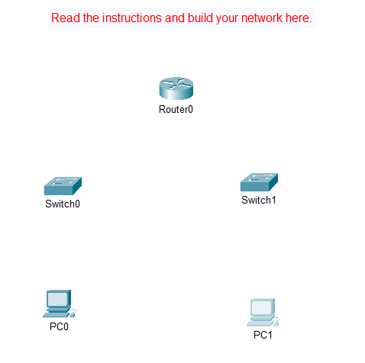

Step 2: Name the devices.
The devices have default names that you will need to change. You will name the devices as shown in the Addressing Table. You are changing the display names of the devices. This is the text label that appears below each device. Your display names must match the information in the Addressing Table exactly. If a display name does not match, you will not be scored for your device configuration.

- Click the device display name that is below the device icon. A text field should appear with a flashing insertion point. If the configuration window for the device appears, close it and try again, clicking a little further away from the device icon.
- Replace the current display name with the appropriate display name from the Addressing Table.
- Repeat until all devices are named.

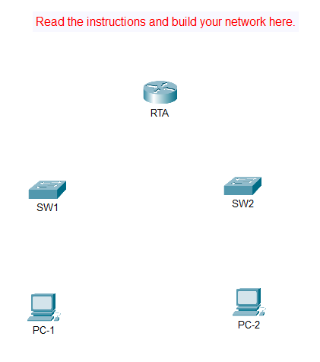

Step 3: Connect the devices.
- Click the orange lightning bolt connections icon in the bottom toolbar.
- Locate the Copper Straight-Through cable icon. It looks like a solid black diagonal line.
- To connect the device, click the Copper Straight-Through cable icon and then click the first device that you want to connect. Select the correct port and then click the second device. Select the correct port and the devices will be connected.
- Connect the devices as specified in the table below.
From Device | Port | To Device | Port
RTA | G0/0 | SW1 | G0/1
 | G0/1 | SW2 | G0/1
SW1 | F0/1 | PC-1 | Fastethernet 0
SW2 | F0/1 | PC-2 | Fastethernet 0

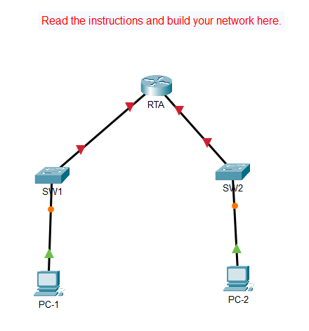

Part 2: Configure Devices
Record the PC addressing and gateway addresses in the addressing table. You can use any available address in the network for PC-1 and PC-2.

Step 1: Configure the router.
- Configure basic settings.
- Hostname as shown in the Addressing Table.
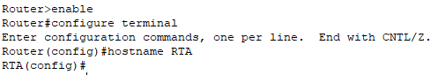
Router>enable
Router#configure terminal
Router(config)#hostname RTA

- Configure Ciscoenpa55 as the encrypted password.
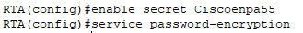
RTA(config)#enable secret Ciscoenpa55
RTA(config)#service password-encryption

- Configure Ciscolinepa55 as the password on the lines.
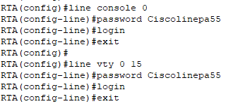
RTA(config)#line console 0
RTA(config-line)#password Ciscolinepa55
RTA(config-line)#login
RTA(config-line)#exit
RTA(config)#line vty 0 15
RTA(config-line)#password Ciscolinepa55
RTA(config-line)#login
RTA(config-line)#exit

- All lines should accept connections.
- Configure an appropriate message of the day banner.
RTA(config)#banner motd ^Unauthorized access is strictly prohibited^

- Configure interface settings.
- Addressing.
- Descriptions on the interfaces.
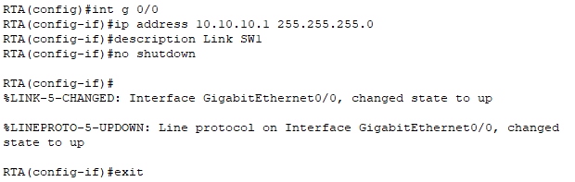
RTA(config)#int g 0/0
RTA(config-if)#ip address 10.10.10.1 255.255.255.0
RTA(config-if)#description Link SW1
RTA(config-if)#no shutdown
RTA(config-if)#exit
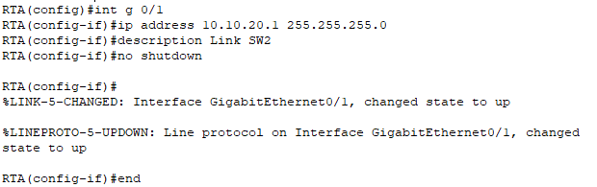
RTA(config)#int g 0/1
RTA(config-if)#ip address 10.10.20.1 255.255.255.0
RTA(config-if)#description Link SW2
RTA(config-if)#no shutdown
RTA(config-if)#end

- Save your configuration.
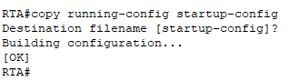
RTA#copy running-config startup-config

Step 2: Configure switch SW1 and SW2.
- Configure the default management interface so that it will accept connections over the network from local and remote hosts. Use the values in the addressing table.

SW1 | 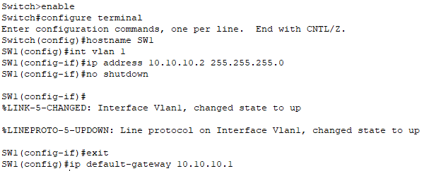  Switch>enable  Switch#configure terminal  Switch(config)#hostname SW1  SW1(config)#int vlan 1  SW1(config-if)#ip address 10.10.10.2 255.255.255.0  SW1(config-if)#no shutdown  SW1(config-if)#exit  SW1(config)#ip default-gateway 10.10.10.1
SW2 | 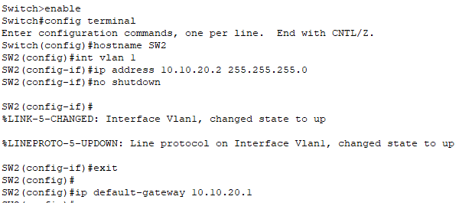  Switch>enable  Switch#configure terminal  Switch(config)#hostname SW2  SW2(config)#int vlan 1  SW2(config-if)#ip address 10.10.20.2 255.255.255.0  SW2(config-if)#no shutdown  SW2(config-if)#exit  SW2(config)#ip default-gateway 10.10.20.1

- Configure an encrypted password using the value in step 1a above.

SW1 | 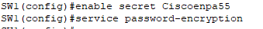  SW1(config)#enable secret Ciscoenpa55  SW1(config)#service password-encryption
SW2 | 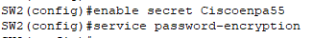  SW2(config)#enable secret Ciscoenpa55  SW2(config)#service password-encryption

- Configure all lines to accept connections using the password from step 1a above.

SW1 | 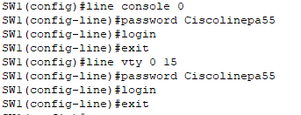  SW1(config)#line console 0  SW1(config-line)#password Ciscolinepa55  SW1(config-line)#login  SW1(config-line)#exit  SW1(config)#line vty 0 15  SW1(config-line)#password Ciscolinepa55  SW1(config-line)#login  SW1(config-line)#exit
SW2 | 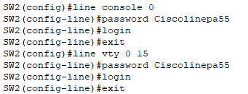  SW2(config)#line console 0  SW2(config-line)#password Ciscolinepa55  SW2(config-line)#login  SW2(config-line)#exit  SW2(config)#line vty 0 15  SW2(config-line)#password Ciscolinepa55  SW2(config-line)#login  SW2(config-line)#exit

- Configure the switches so that they can send data to hosts on remote networks.
- Save your configuration.

SW1 | 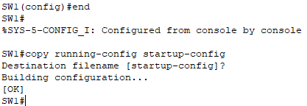  SW1(config)#end  SW1#copy running-config startup-config
SW2 | 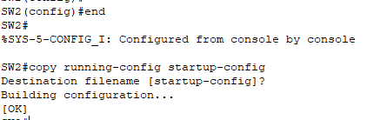  SW2(config)#end  SW2#copy running-config startup-config

Step 3: Configure the hosts.
Configure addressing on the hosts. If your configurations are complete, you should be able to ping all devices in the topology.

PC-1 | 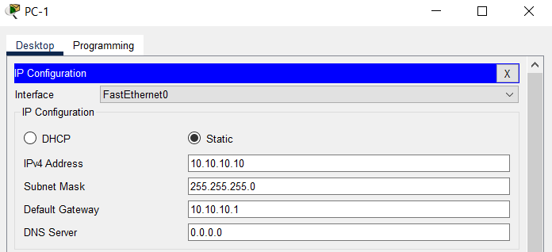
PC-2 | 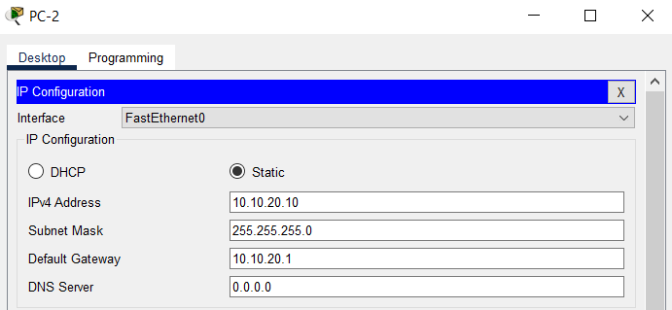

Ping from PC-1 to PC-2 | 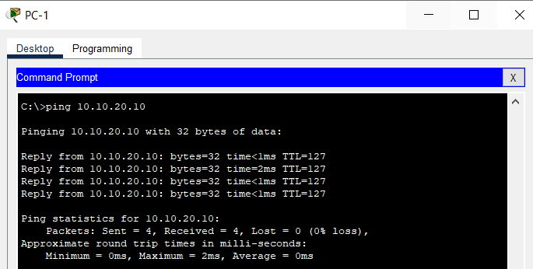
Ping from PC-2 to PC-1 | 